**St John Henry Newman Catholic School**

**Headteacher:** Mr John McAuley BA (Hons) MEd

**Address:** Scalegate Road, Carlisle, CA2 4NL

**Telephone:** 01228 404942 **Email:** office@newman.cumbria.sch.uk

**Website:** www.newman.cumbria.sch.uk

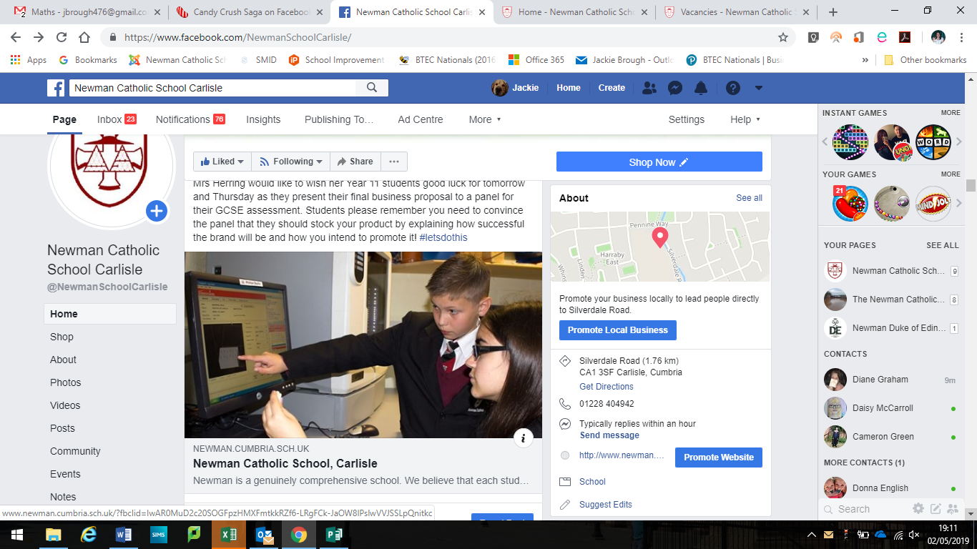



**St John Henry Newman Catholic School**

**Contents**

|  |  |
| --- | --- |
| Page 3 | Letter of welcome from the Headteacher |
| Page 4 | Our Location |
| Page 5 | New School Building |
| Page 6 | Advert |
| Page 7 - 8 | Job Description & Person Specification |
| Page 9 -10 | Mission Statement |

Also included with this application pack:

* Attachments - Notes to Applicant
* Application Form
* Rehabilitation of Offenders Form – issued at shortlisting stage
* Self-Disclosure Form – issued at shortlisting stage
* Recruitment Monitoring Form
* Consent to Obtain Reference Form
* School Privacy Notice - Staff
* Staff Code of Conduct Policy
* Child Protection Statement
* Equality Act Reasonable Adjustment Statement



**St John Henry Newman Catholic School**

Welcome to St John Henry Newman Catholic School. We are a genuinely comprehensive school and believe that our mission is to nurture each child by placing Christ and the teaching of the Catholic Church at the centre of their lives.

We integrate Gospel values and the teachings of the Catholic Church into every aspect of learning, teaching and the totality of school life.

In the words of our patron St John Henry Newman, “To live is to change and to be perfect is to have changed often”; and so we have high expectations of our pupils; we expect them to work hard, to play hard and to take a full part in the life of the school. In return, we strive to provide the best teaching and guidance in a caring and supportive environment, where pupils are challenged and give of their best.

Strong pastoral care is vital to our success and creates a happy and caring atmosphere. As a smaller school, we get to know our pupils well; their well-being is our foundation. This strong pastoral care enables us to support our pupils, not only with their academic work, but also in the varied extra-curricular activities, which are hugely important as they develop into young adults.

It is an exciting time to join Newman. Following the flooding of our site in Carlisle we have now moved to a purpose-built modern school in a developing area of Carlisle, the garden village. After a turbulent time following the flood, the school is rapidly improving and was recently commended by Ofsted for the improvements being made in the quality of teaching, the progress of pupils, and for the highly effective pastoral support. Inspectors’ findings confirmed that a journey of school improvement is underway.

We want our pupils to enjoy their education – to be happy, safe and secure and to grow in God’s love so that when they leave the school, they are equipped to change the world and make it a better place.

John McAuley

Headteacher

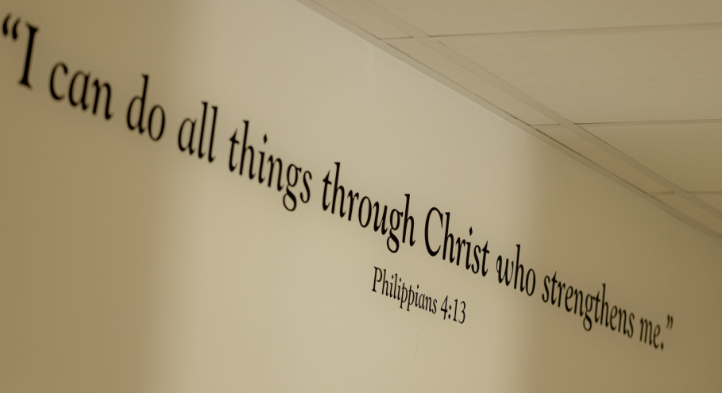

**St John Henry Newman Catholic School**



**Why choose this location**

St John Henry Newman Catholic School is located in Carlisle - the Border City - which is the main shopping, commercial and industrial centre in the north Cumbria. The city sits on the doorstep of both the Lake District and Hadrian’s Wall and blends 2000 years of history with a vibrant 21st century city.

The school has moved to a brand new build, located in the south of the city in a developing area known as the garden village.

The district of Carlisle, with a population of over 100,000, lies 10 miles south of the Scottish borders at the confluence of three rivers.

Originally established as a Roman settlement to serve the forts on nearby Hadrian’s Wall, it is the main commercial centre for north Cumbria. It has a long and interesting history, with Cumbria’s only cathedral and Carlisle Castle, a mediaeval fortress.

Easily accessed from the M6 motorway and A69 east-west route, Carlisle is also a major railway junction, with routes to London, Scotland, Newcastle, west Cumbria and the famous Settle-Carlisle railway.

Cumbria is a predominantly a rural county, considered one of the most beautiful regions of the UK, and includes the whole of the Lake District National Park, the Eden Valley, the North Pennines, the Furness Peninsula, and part of the Yorkshire Dales. The area has provided inspiration for generations of artists, writers and musicians. The county has some beautiful coastlines, vibrant towns and idyllic rural villages.

The quality of life is hard to beat and it is easy to see why so many people are drawn to Cumbria to live and work.

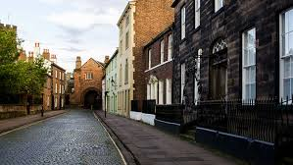

**St John Henry Newman Catholic School**

**Our New School**

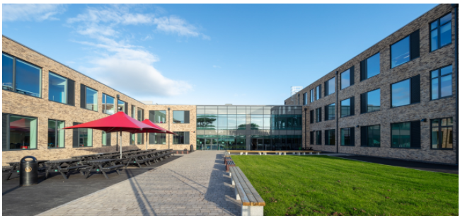

It is an exciting time for Newman, as we have moved to a new build school in the “garden village” area of Carlisle. Our school is a £15million new build in a rural location on the edge of the city. The school has been designed to provide the highest standards of education for our pupils and areas have been purpose built to allow staff to teach effectively in their subject areas.

 **St John Henry Newman Catholic School**

Exam Invigilators

CE2: £12.00 per hour

We are looking to recruit additional Exam Invigilators to ensure the fair and proper conduct of examinations in our school.

If you are available for morning and/or afternoon sessions and would like to apply, please contact the school by emailing vacancies@newman.cumbria.sch.uk or download an application pack from our website at <http://newman.cumbria.sch.uk/Vacancies/>

Previous experience is not necessary, as full training will be provided.

Please note, due to the nature of this role the post is casual with hours worked processed by a timesheet.

Our school has a distinctive caring and Christian ethos with the emphasis on the individual and supporting staff and pupils in fulfilling their full potential.

St John Henry Newman Catholic School is committed to safeguarding and promoting the welfare of young people. This post will be subject to satisfactory DBS, health checks and a six month probation period.

For an informal chat about the post or to request to visit our school please contact Mrs Farrier by email: cfarrier[@newman.cumbria.sch.uk.](mailto:marybrookes@newman.cumbria.sch.uk.)

Completed application forms can either be emailed to the address above or by post addressed to HR and Finance Department.

Shortlisted candidates will be contacted by telephone or email.

 **St John Henry Newman Catholic School**

**Job Description**

**POST TITLE:** Exam Invigilator

**Responsible To:** Exams Officer

**JOB FAMILY:** Customer Engagement

**PG NUMBER:** PG4047

**JOB PROFILE:** CE **Scale point**: 2

**Main Purpose:** To ensure the fair and proper conduct of examinations in an environment that enables students to perform to the best of their ability.

**PRINCIPAL ACCOUNTABILITIES:**

To follow and enforce exam procedures and regulations, assist in the collection and distribution of exam papers in accordance with procedures and to supervise candidates leaving exam venues, ensuring that equipment and stationery are not removed without authorisation and that candidates leave venues in an orderly manner.

To assist the Exams Officer with other examination processes, including collating candidate name cards and assisting with the packing of examination papers as required.

**KEY TASKS:**

* To arrive at school a quarter of an hour before the examination start time.
* Ensure that mobile phones are switched off and handed in.
* Ensure that candidates are aware of the start and finishing times of examinations.
* To assist candidates in finding their seats and advise about possessions permitted inside examination venues.
* To support students who need equipment, such as pencils, rulers, calculators, etc.
* To hand out additional materials, such as answer sheets, or graph paper.
* To record breaches of conduct on the conduct log.
* To report to the lead invigilator if you feel there has been any breach of security.
* To record the start time of any students who arrive late and ensure that they receive the relevant instructions and information.
* To be aware of the evacuation procedure.
* Escort candidates on toilet breaks, ensuring that regulations are observed at all times.
* To supervise the candidates throughout the exam, moving around the room quietly and unobtrusively.

**Other Duties:**

* Contribute to the overall ethos, work and aims of the school.
* Be aware and comply with policies and procedures relating to data protection, child protection, safeguarding, health & safety, security and confidentiality reporting all concerns to an appropriate person in accordance with school policies.
* Contribute to risk assessments and promoting a healthy and safe working environment.
* Participate in training and other learning opportunities in performance management as required.
* Any other duties the Headteacher may direct within the conditions of service and workforce reform policy.

**REVIEW:**

This job description may be reviewed from time to time with the Headteacher. Whilst every effort has been made to explain the main duties and responsibilities of the post, each individual task will not necessarily be identified.

**John McAuley**

**Headteacher**

**March 2023**

 **St John Henry Newman Catholic School**

**Mission Statement**

*Our mission is to educate our pupils in the wholeness of mind, body and spirit through the teachings of Jesus Christ as proclaimed by the Catholic Church by placing Him at the centre of pupils' lives.*

*Our school commits itself to the principles of Catholic education and academic excellence, leading our pupils from shadows and images to the fullness of the Truth, as envisioned by the St John Henry Newman. The school community recognises that excellence in education can best be achieved, and future leaders nurtured, within a living tradition rooted in the Love and Truth of Christ.*

*We encourage pupils to cultivate Christian virtue and an appropriate sense of social responsibility.*

*We inspire an enthusiasm for life-long learning and are committed to success for all.*

**St John Henry Newman Catholic School**

**Governors’ Strategic Vision 2018-2023**

This text sets out our aspirations for St John Henry Newman Catholic School and provides a description of the school the governors would like to see evolve as the manifestation of their ambitions.

Each year’s School Improvement Plan will take us closer to achieving these goals and will represent the practical steps required to deliver this vision.

**We will develop a school which is characterised by:**

* Christian values, where Catholic teaching is at the centre of every aspect of school life, and kindness and compassion are qualities which are shared by the whole school community
* equal respect for all members of the school community in which diversity is welcomed and celebrated
* dedicated, highly professional and committed staff who fulfil their various roles to the highest of standards and work effectively as a team
* fostering high aspirations and determination in our pupils, and driving them to be high achievers in all aspects of their learning and development
* a safe, nurturing and inclusive outlook

**As a result of our collective efforts, we expect our pupils to be:**

* well rounded young people, independent, confident and articulate, outward facing and ready to make a positive difference in the world as responsible citizens in a tolerant and democratic society
* happy and able to fulfil all dimensions of their human potential: spiritual, academic, personal and social
* shaped by Christian values, and willing to contribute actively in their faith and secular communities, providing a positive example to others
* confident in their abilities and equipped to achieve excellence in their studies leading to success in continuing education or training and future careers
* both leaders and good team players with a strong sense of self-esteem as well as respect for others
* the best that they can be, behaving in such a way that all can be proud of them
* self-disciplined and courteous, setting an example to others

**The school will provide an environment which is:**

* an inspirational place in which to learn: spacious, light, attractive and stimulating
* suitable to meet all needs – physical, academic, personal, social and spiritual
* furnished with a distinctive and prominent working chapel open to all, at all times, with regular Masses
* supportive of learning in all domains, flexible and responsive to the changing curricular requirements of the 21st Century
* responsive to the progression routes of all pupils, including the provision of high quality post-16 programs within its own distinctive sixth form.
* an environment which brings pupils together, with communal and recreational spaces conducive to a civilised experience
* safe, secure and appropriate to the diverse needs of the pupil’s community
* well-resourced with the equipment and materials required to provide the best contemporary education possible